www.artnc.org

Weather Forecasting
Writer: Jennifer Rogers, Science Teacher
Grade Level: 7th
Related Big Picture Concepts: Environment, Observation, Variation
Subject Areas: Science, Art
Essential Question: How do types of clouds vary in appearance and altitude? How can weather conditions be used to create a forecast?
Abstract: Students will explore the different types of clouds and the weather that is associated with each type of cloud. Students will observe how weather is depicted in paintings, generate a weather report for a certain painting, and create their own cloud paintings.
Duration: 200 minutes
Focus Works of Art:
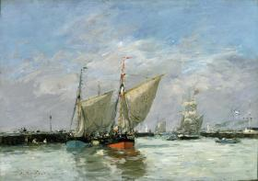
Eugène Boudin (French, 1824-1898)
Trouville, The Jetties, High Tide, 1876
Oil on canvas
12 1/4 x 17 3/4 in. (31.1 x 45.1 cm)
www.artnc.org/node/442
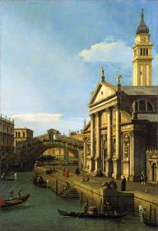
Canaletto (Giovanni Antonio Canal) (Italian, 1697–1768)
Capriccio: The Rialto Bridge and The Church of S. Giorgio Maggiore
circa 1750
Oil on canvas
66 x 45 in. (167.6 x 114.3 cm)
www.artnc.org/node/306

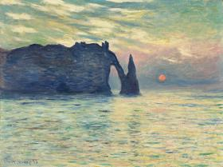
Claude Monet (French, 1840-1926)
The Cliff, Étretat, Sunset, 1882-1883
Oil on canvas
23 13/16 x 32 3/16 in. (60.5 x 81.8 cm)
www.artnc.org/node/310

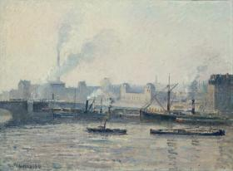
Camille Pissarro (French, 1830-1903)
The Saint-Sever Bridge, Rouen: Mist, 1896
Oil on canvas
23 3/4 x 34 1/4 in. (60.3 x 87.0 cm)
www.artnc.org/node/443

For another example see:
http://collection.ncartmuseum.org/collection11/view/objects/asitem/id/705

North Carolina Standards Correlation:
Science 7.E.1.4
Art 7.V.2.2 , 7.V.3.3, 7.CX.1.1

Student Learning Objectives:
- Students will apply knowledge of various types of clouds and their relationship to weather systems.
- Students will explore en plein air paintings and analyze the impact of technology on artists' working materials and processes.
- Students will use observational skills and apply knowledge of art techniques and materials to create a personal work of art based on nature.
Activities:
- Have students create a windowpane foldable with four flaps for notes on clouds. Instruct students to label each flap with one type of cloud: cirrus, stratus, cumulus, cumulonimbus.

- Have students count off by fours. Assign one type of cloud for each number (1–cirrus, 2–stratus, 3–cumulus, 4–cumulonimbus).

- Show the Types of Clouds video (see Lesson Resources). Ask students to take notes under the flap of the foldable on the type of cloud that was assigned to their number.

- Once video is complete, have students get into groups based on the type of cloud they took notes on during the video (for example, students who took notes on cirrus clouds should be together). Students should work together, share notes, and use the textbook and Internet resources to describe their type of cloud. Students in each group should become "experts" about their type of cloud. Students will finish by drawing a picture of their type of cloud on the outside flap of the foldable and writing a description and any other facts under the flap.

- Rearrange the students into new groups of four. Each of the four students should be an "expert" about one of the four different types of clouds. Within the group, students will teach each other about their cloud type. During this time, students should complete their foldables with a drawing of the cloud on the front of the flap and facts on the inside.

- To review the types of clouds and the altitudes where they are formed, instruct students to complete the Types of Clouds Worksheet (see Lesson Resources).

- Review students' answers to worksheet. Discuss types of clouds and the weather that is associated with each type.

- An extension to review the cloud types is to show the Types of Clouds Music Video or the Types of Clouds PowerPoint Presentation (see Lesson Resources). During the PowerPoint, students can write answers on individual whiteboards or discuss as a class.

- Introduce students to Boudin's Trouville, The Jetties, High Tide. Discuss the painting as a group. Appoint a note taker to write down students' responses to questions. Questions may include:
- What do you see in this painting? (Students should point out things that are observable in the painting)
- What type of clouds do you notice? (Students should conclude the clouds are either cumulus or cumulonimbus)
- Describe what you think the weather would be like if you were able to step into this painting. (Students should describe temperature, wind speed, season, etc.)
- What clues helped you determine the temperature and type of weather in the painting? (bright sunlight, shadows in water, cool colors giving clues regarding the temperature, full sails, flag blowing)
- Do you think the artist painted this scene outside or inside? (Painted most of it outside)
- Name some advantages/disadvantages of working outside. (Answers will vary)
- Name some advantages/disadvantages of working inside. (Answers will vary)
- Give background information about en plein air painting. Tell students that Boudin painted outdoors and encouraged others to do the same. As a class or in small groups, have students brainstorm materials that an artist might need to paint outside. Appoint a note taker for each group or the whole class to make a list of the materials. Discuss items that may be missing from the lists. Items may include portable easel, palette, paint tubes, weather gear (sweater, umbrella, hat, etc.), glasses, brushes, portable stool or chair, sketchbook, canvases, pencils, etc.

- Discuss as a class which of these items would have been available to Boudin during the time that he completed this painting (around 1876). Ask: What items would not have been available? (plastic containers, sunscreen, cell phone with Internet access for a weather report).

- Discuss the role of technology in preparing for weather. Ask: What do you need to know before you spend the day outside? (temperature, precipitation, how to dress) How do you find out what the weather will be? (Web site, TV report, newspaper) How do you think Boudin and other artists prepared themselves for painting outside without having a weather forecast on the morning news? (clouds, climate information, almanac)

- Refer back to the students' responses to the discussion questions about Boudin's Trouville, The Jetties, High Tide. Using the students' responses, work as a class to put a weather report together for this painting. Remind students of the important elements of forecasting the weather (temperature, wind speed, wind direction, precipitation). Demonstrate a sample weather report about the Boudin painting.

- Tell students that they will be working in a group to create a weather report for either a French or an Italian painting. Divide the class into groups and assign each group one of the following paintings: Capriccio: The Rialto Bridge and The Church of S. Giorgio Maggiore by Giovanni Antonio Canal (Italian), The Cliff, Étretat, Sunset by Claude Monet (French), The Grand Canal at the [Rio di] Ca’ Foscari by Michele Marieschi (Italian), and The Saint-Sever Bridge, Rouen: Mist by Camille Pissarro (French).

- Ask students to discuss the painting within their groups. Have students complete the Weather or Not Data Handout (see Lesson Resources) during the group discussion. Students should use the Weather or Not Forecast Tools Handout and their cloud foldable to determine the weather forecast.

- Students should use the information to come up with a creative weather forecast presentation. Students can use props, poster board, costumes, etc. to present their forecast.

- Project each painting and allow students to present their weather reports. Discuss the elements of the painting and the evidence that the students used to determine the weather conditions.

- Allow students to create their own cloud paintings. Students should use the NCMA paintings from the weather reports as inspiration. Students should show a specific type of cloud in their painting as well as evidence of specific weather conditions.

- As an alternative assignment, instead of having students create a cloud painting indoors, have students organize materials and go outside to draw or create small en plein air paintings. Encourage students to work quickly to capture the quality of light and weather conditions.

- Ask students to complete a reflection about their cloud painting. Project the Cloud Painting Reflection PowerPoint (see Lesson Resources) for students to reference.

Assessments:
- Types of Clouds Worksheet (see Lesson Resources) will demonstrate students' understanding of types of clouds and weather associated with each cloud.
- Weather or Not Data Handout (see Lesson Resources) will assess students' discussions and analysis of the painting. Rubric will assess discussion, answers, and presentation.
- Class discussion and group lists can be used to assess students' analysis of weather data and factors.
- Cloud painting and reflection will demonstrate students' ability to use observation skills and different techniques to create art.

Resources:
Vocabulary:
cirrus clouds—wispy white clouds, usually made of ice crystals, that
form at high altitude
stratus clouds—low, layered clouds that stretch over large portions of
the sky
cumulus clouds—low- to mid-level clouds that can be described as
"puffy" or "cottonlike"
cumulonimbus clouds—tall, dense clouds involved with thunderstorms
and other intense weather
en plein air—a French expression meaning "in the open air"; used to
describe the act of painting outdoors

Materials:
Paper for foldable
Crayons or colored pencils for foldable
Cardstock for painting
Paint
Paint brushes
Projector
Props, costumes, poster board, etc. for weather report presentations

Lesson Resources:
Directions for windowpane foldable
http://acacomputerlab.com/Documents/Window%20Panes%20Template.ppt

Types of Clouds Video
http://www.iteachbio.com/Earth_Science/Earth_Science/TypesofClouds.mov
Types of Clouds Internet Resources
http://science.howstuffworks.com/dictionary/meteorological-terms/cloud1.htm
http://science.nationalgeographic.com/science/earth/earths-atmosphere/clouds-article/
http://students.estrellamountain.edu/drakuna/studentfrontpageprojects/DavidIreland/new_page_3.htm
http://asd-www.larc.nasa.gov/SCOOL/tutorial/clouds/cloudtypes.swf
http://wvscience.org/clouds/Cloud_Key.pdf

Types of Clouds Worksheet http://www.superteacherworksheets.com/weather/cloud-types-article.pdf

Types of Clouds Music Video http://www.watchknow.org/Video.aspx?VideoID=19624

Types of Clouds PowerPoint Presentation
http://artnc.org/sites/default/files/documents/Types%20of%20Clouds.pdf
Weather or Not Forecast Tools Handout

Cloud Painting Reflection PowerPoint
http://artnc.org/sites/default/files/documents/Cloud%20painting%20reflection.pptx
Weather or Not Activity
With your group, inspect the painting for details to create a weather report. Additional weather information is included for reference. Come up with a creative way for your entire group to deliver a weather report to the class. You can deliver it in the style of a television news or radio report. You can use the back of this paper to write out your weather report.
- What do you see in the painting? (What things can you actually point out?)

- What kind of clouds can you pick out? Describe the characteristics of these clouds.

- What does the weather look like? Consider the following:

  - Location:

  - Season:
  - Temperature:
  - Wind:

- What evidence can you use from the painting that helped to determine what the weather is like? Details!

Weather or Not Rubric:
Weather or Not Handout __________(40 points)
(Handout is complete with thoughts and ideas from all group members)
Teamwork __________(20 points)
(Group works together to complete task. All students contribute)
Presentation __________(30 points)
(Weather report presented in a creative, professional manner. All group members participate in presentation.)
Self-assessment __________(10 points)
(How well did your group work together? What grade would you give yourselves?)
Weather Forecast Tools
Average Weather
 | Normandy, France |  | Venice, Italy
 | (max/min ˚F) | Avg Precipitation | (max/min ˚F) | Avg Precipitation
January | 44˚/33˚ | 2.6 inches | 44˚/33˚ | 2.3 inches
February | 46˚/35˚ | 2.1 inches | 46˚/35˚ | 2.1 inches
March | 51˚/37˚ | 1.7 inches | 51˚/37˚ | 2.3 inches
April | 55˚/41˚ | 1.8 inches | 55˚/41˚ | 2.5 inches
May | 62˚/46˚ | 2.1 inches | 62˚/46˚ | 2.7 inches
June | 68˚/50˚ | 1.7 inches | 68˚/50˚ | 3.0 inches
July | 71˚/53˚ | 1.9 inches | 71˚/53˚ | 2.5 inches
August | 71˚/53˚ | 2.2 inches | 71˚/53˚ | 3.3 inches
September | 68˚/51˚ | 2.5 inches | 68˚/51˚ | 2.6 inches
October | 59˚/40˚ | 2.8 inches | 59˚/40˚ | 2.7 inches
November | 51˚/40˚ | 2.9 inches | 51˚/40˚ | 3.4 inches
December | 46˚/35˚ | 2.3 inches | 46˚/35˚ | 2.1 inches
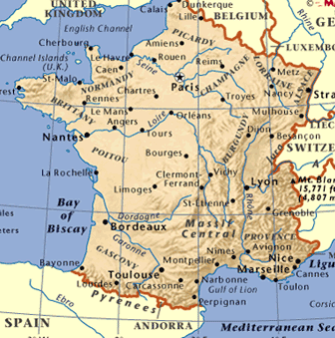
Normandy, France climate information
Normandy is on the west coast of France and has a warm climate.
Good levels of rain mean that the countryside is green but there
are usually more sunny days than cloudy or rainy days. Due to its
northern latitude and coastal position, the weather does not get
to the high temperatures as seen elsewhere in France. Weather can
be unpredictable. However occasional days reaching 80˚ F are not
unusual in the summer and the winter months are relatively mild.
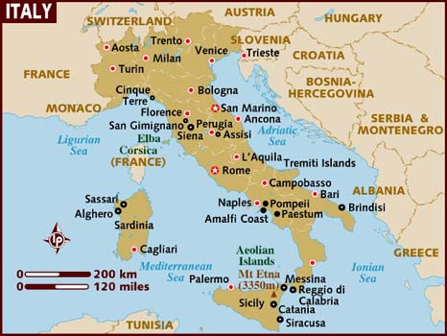
Venice, Italy climate information
In summer, the northern parts of Italy are warm with occasional rainfall,
but winter conditions in Venice are dominated by cold, damp and fog. Being
located in North-East Italy, the climate in Venice changes dramatically
throughout the year. In the winter the temperature can drop below freezing,
while in the summer the temperatures can rise to 35C/96F. As might
be expected from its canals, the humidity remains high all year round.
Because it is surrounded by water, in Venice, cooler temperatures feel colder
and the warmer temperatures hotter.
Sample Weather Report
WEDNESDAY NIGHT: Mostly cloudy skies this evening then clearing overnight and cooler and also less humid. Lows in the mid 40s-50. We had a cold front move through the area today. This front brought the clouds and rain with only a few hundredths of an inch seen across the area. A second front will be dry with no rain and no cloud cover but it does bring a cooler and drier air mass into the area for Friday. Winds tonight will be variable and light.
THURSDAY: Sunny, breezy and less humid. Highs in upper 70s. The next cold front comes in late this afternoon. Ahead of the front will be bright and breezy but once the front passes it will be cooler and less humid. Wind: W at 15-25 m.p.h.

